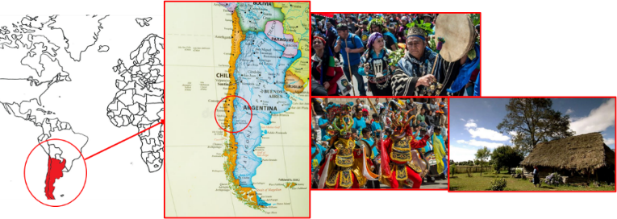
Problem 1. Mapudungun (15 marks)
Mapudungun is an Araucanian language spoken by approximately 258,000 people (as of 2012) in Chile and Argentina.
Note that in Mapudungun, y is a vowel; c, č, ʎ, θ, ŋ, n̪ and l̪ are consonants; an acute accent as in á marks a stressed syllable.
Nouns in Mapudungun can be classified into two types: simplex nouns and nominal compounds. Here are some simplex nouns, with the stress marked and meanings given:
koʎkóma coot | anúŋka plant
n̪amýn foot | waŋilén star
mawíθa woodland | pifýʎka flute
elkoɲíwe womb | acuʎpéɲ floating ash

(a) yna itch | (c) l̪afken̪ sea
(b) puɲpuja armpit | (d) piwke heart
1.1) On your answer sheet, assign stress to the following simplex nouns:

Here are some compound nouns, with the stress marked, and both the meaning and literal translations given:
cafó-kučán cold (lit. ‘cough-disease’) | kuθi-fóro spine (lit. ‘mortar-bone’)
caŋúʎ-namýn̪ toe (lit. ‘finger-foot’) | iló-čewa dogmeat (lit. ‘meat-dog’)
loŋkó-kacíʎa head of wheat (lit. ‘head-wheat’) | ŋé-čewa dog’s eye (lit. ‘eye-dog’)
myta-píru snail (lit. ‘horn-worm’) | wecóθ-yu nostril (lit. ‘hole-nose’)

1.2) Assign stress to the following nominal compounds.
(a) mapu-ce Mapuche people (lit. ‘land-people’) | (e) wenu-mapu heaven (lit. ‘high-land’)
(b) lypi-acawaʎ chicken wing (lit. ‘wing-chicken’) | (f) foro-caʎwa fishbone (lit. ‘bone-fish’)
(c) kyčal-ko petroleum (lit. ‘fire-water’) | (g) loŋko-moyo nipple (lit. ‘head-breast’)
(d) θomo-lamŋen sister (lit. ‘woman-sister’) | (h) ciʎkatuwe-ruka school (lit. ‘writing-house’)

Below are some Mapudungun verb forms and their translations, with stress marked.
yčýfkelafíjmi you do not usually throw it | l̪áŋlawájmi you will not die
čipákelájmi you do not usually go out | yčyffín I throw it
θewmálawafíj s/he will not make it | amulájmi you do not go
l̪aŋýmkefín I usually kill it | yčyfŋélajmi you are not thrown
leliŋékelájmi you are not usually watched | lelifíjmi you watch it
amuýmfij s/he causes it to come | jékeláj s/he does not usually bring
θewmafín I make it | θewmaýmwafíj s/he will cause it to make

1.3) Assign stress to and translate the following verbs:
(a) leliŋelawan | (d) jeŋekelawaj
(b) jeŋelajmi | (e) θewmakejmi
(c) čipalawan | (f) yčyfymkelawafij

Solution and marking.
Scoring: (max 38)
1.1: Max 4 – 1 per correct word
1.2 Max 16 – 2 per correct word
1.3 Max 18 – 2 per correct stress assignment, 1 per correct translation. Accept translations with the same meaning. Accept any 3rd person pronoun(s) for s/he, it.
Q 1.1 | (a) ýna | Q 1.2 | (a) mapu-cé | (e) wenu-mápu
Q 1.1 | (b) puɲpúja | Q 1.2 | (b) lypí-acawáʎ | (f) foró-caʎwa
Q 1.1 | (c) l̪afkén̪ | Q 1.2 | (c) kyčal-kó | (g) loŋkó-moyo
Q 1.1 | (d) píwke | Q 1.2 | (d) θomó-lamŋén | (h) ciʎkatuwe-rúka
Q 1.3 | (a) leliŋélawán  I will not be watched |  | (d) jeŋékelawáj  s/he will not usually be brought
Q 1.3 | (b) jeŋélajmi  you are not brought |  | (e) θewmakéjmi  you usually make
Q 1.3 | (c) čipálawán  I will not go out |  | (f) yčyfýmkelawafíj  s/he will not usually cause it to throw

Commentary
We describe three stress rules, used to assign stress to a segment X:
- If X is monosyllabic, X is stressed
- Else if the final syllable of X is closed, stress the final syllable
- Else stress the penultimate syllable.
In simplex nouns, apply rules (a)-(c).
In compound nouns, stress the final syllable of the first element, and apply (a)-(c) to the second. If two stressed syllables are adjacent, discard the stress in the modifying noun and keep the stress in the head noun.
In verbs, stress the final syllable of the root, stress a voice suffix if present, then apply (a)-(c) to the other affixes. If two stressed syllables are adjacent, discard a stress in the root, and keep the stress in a voice suffix.
The verb has the following form:
ROOT | VOICE SUFFIX | ASPECT | POLARITY | TENSE | OBJECT | SUBJECT
 | -ym causative  -ŋe passive | -ke habitual | -la negative | -wa future | -fi 3s | -n 1s  -jmi 2s  -j 3s

An alternative analysis of the verb treats it in the same way as a compound noun, with the first part being the root + voice affixes, and the second part being the remaining suffixes. The “head” is then usually the second part, unless there is a voice suffix present.

